Image enhancement

An enhancement algorithm manipulates an image to improve its information. The information an image contains will be made more visible. For example the colors and brightness can be balanced to improve the details in an image or the image can be sharpened.  
  
Histogram equalization

Histogram equalization is ideal to be used in situations where an image has been captured in bad conditions(weather/lighting). Histogram equalization is usually used to adjust the contrast in images.

First a histogram will be generated on a color channel. The histogram displays the intensity of a color value in the image:

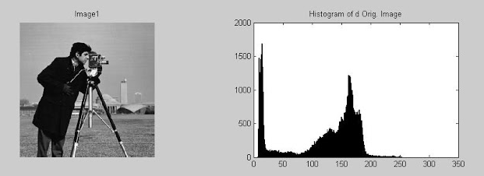

Figure 1 – Histogram on a 256 grayscale level

Secondly all color intensities will be equally distributed over the histogram, which gives us an image with a higher contrast. All color values will be recalculated by looking in the histogram table.

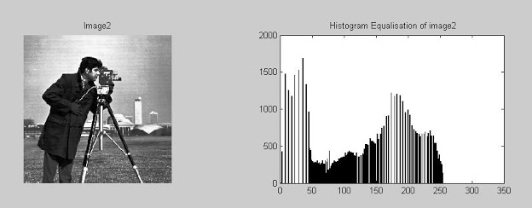

Figure 2 – Equalized histogram on a 256 grayscale level

Advantages:  
Simplicity of the algorithm.  
The algorithm is invertible.

Disadvantages:  
The brightness of high contrast images may be reduced.  
Often produces unrealistic effects with photos.  
The contrast of background noise may be increased while usable information is being reduced.

Source:  
<http://en.wikipedia.org/wiki/Histogram_equalization>  
[Les 1 - Introductie, kleurruimte en histogrammen.pdf](https://cursussen.sharepoint.hu.nl/fnt/55/TCTI-V2VISN1-13/Studiemateriaal/Les-slides/Les%201%20-%20Introductie,%20kleurruimte%20en%20histogrammen.pdf) – Slides made by Arno Kamphuis.  
<http://amarsinghhpcs.blogspot.nl/2013/01/histogram-equalization-of-bmp-image-in-c.html>  
<http://www.webopedia.com/TERM/I/image_enhancement.html>

Images source:  
<http://www.rocktheit.com/2012/09/matlab-program-to-apply-histogram.html>  
  
Unsharp masking

The unsharp masking algorithm is used to sharpen images. Unsharp masking works by combining information from three images.

http://cdn.cambridgeincolour.com/images/tutorials/usm_text-orig.pngThe first image is the original image that has to be sharpened.

Figure 3 – Original image.

http://cdn.cambridgeincolour.com/images/tutorials/usm_text-blur.pngThe second image is the unsharp mask, it is created by adding a Gaussian blur to the original copy and subtracting the blurred image from the original image.

**http://cdn.cambridgeincolour.com/images/tutorials/usm_text-orig.png -  
 =** Unsharp Mask Image

Figure 4 – Original image minus the blurred copy equals the unsharp mask.

The third image is a copy of the original image with an increased contrast. http://cdn.cambridgeincolour.com/images/tutorials/usm_text-HCorig.png

Figure 5 - Higher contrast version.

http://cdn.cambridgeincolour.com/images/tutorials/usm_text-sharp.pngFinally the sharpened image can be created. For every pixel in the unsharp mask the brightness will be checked. If the brightness is 100%, the color value of the high contrast image will be used in the output image. If the brightness is 0% the color value of the original image will be used. For all other brightness percentages between 0 and 100, the color values of the original image and the higher contrast version will be mixed together into a new value. The output image is a sharpened image.

http://cdn.cambridgeincolour.com/images/tutorials/usm_text-orig.png

Figure 6 – The original image(left) compared to the sharpened image(right).

Advantages:  
Image will be less blurry.

Disadvantages:  
Not only the edges will be sharpened but everything will be sharpened.  
Noise will be sharpened.

Sources:  
<http://stackoverflow.com/questions/2938162/how-does-an-unsharp-mask-work>  
<http://www.photokaboom.com/photography/learn/Photoshop_Elements/sharpening/USM_1.htm>

Images source:  
<http://www.cambridgeincolour.com/tutorials/unsharp-mask.htm>